Organizational Risk Assessment – COVID-19

Organizational risk assessments are useful for organizations to identify and plan for dangers or hazards that have the capability to harm the organization and/or it’s subsystems. The COVID-19 pandemic is a good example of a legitimate hazard that has and continues to affect long-term care homes across the world. Recognizing the severity of this pandemic and its effects on the older adult population, an organizational risk assessment has been created for Sandfield Place for its facility as a whole. Below, the five-step organization risk assessment has been completed, recognizing hazards relevant to a long-term care facility.

Step 1: Identify the hazards
- COVID-19 (virus) an infectious virus capable of rapid transmission and causing notably severe respiratory symptoms compared to that of the ‘common cold’ or seasonal influenza
- Visitors (family + external essential personnel) acting as carriers of the virus
- Unvaccinated residents, staff and visitors
- Interruptions in supplies delivered to the home
- Breakdowns in IPAC procedures (hand hygiene, disinfection, poor mask etiquette etc.)
- Specificity and sensitivity (not 100%) of rapid test kits used to screen individuals with symptoms (if no contact with COVID positive case). Allows for the possibility of a false positive or false negative
- Staffing shortages due to illness, vaccine mandates or other reasons
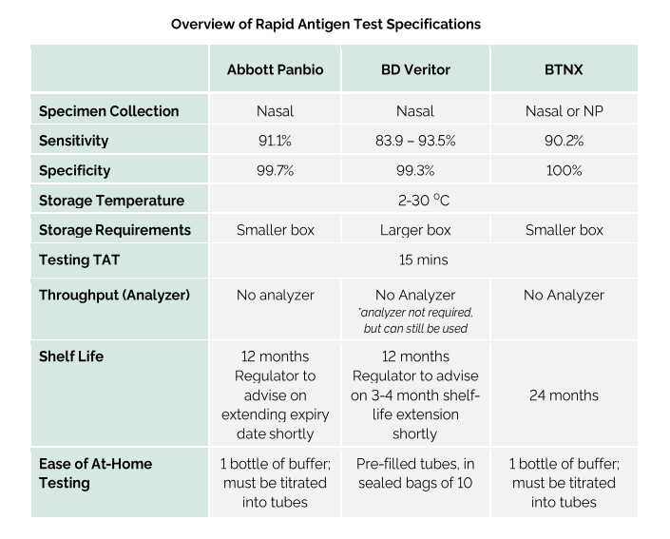
Step 2: Decide who might be harmed and how
- Residents (especially those who are elderly, have co-morbidities, have chronic respiratory issues or a combination of any factors. These individuals risk severe infection)
  - Unvaccinated residents: More severe infections have been prominent in the unvaccinated population. Unvaccinated individuals are found to have worse health outcomes, increased hospitalization and mortality rates following infection.)
- Staff members (particularly those who are unvaccinated)
- Visitors (family + external essential personnel)
*all aforementioned individuals risk exposure to COVID-19 infection, which can range from mild respiratory symptoms up to and including death from severe infection

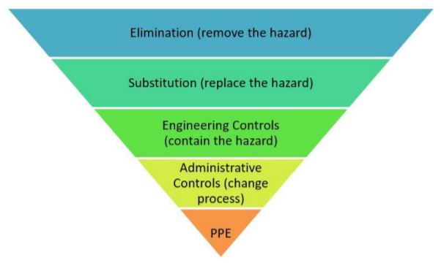

Step 3: Evaluate the risks and decide on precautions.
- Early identification of possible symptoms and isolation + testing when necessary (as soon as possible).
  - Tests include other respiratory agents as well such as influenza.
- Increase in IPAC measures including provision of PPE, increased auditing and increased cleaning of high contact surfaces.
- Collaboration with external organizations such as local health unit (Eastern Ontario Health Unit (EOHU) - for guidance and support)
- Reduction of services to essential services only – unless otherwise permitted under ministry directives as part of ‘reopening Ontario’.
- Scheduling of visits for residents within the home when possible.
- Vaccination education and clinics for residents, staff and visitors (ongoing).
- ‘Decision tree’ for staff call-ins to decide if they can still work based on exposure to COVID-19 and symptomology
- Staff education:
  - IPAC measures
  - Vaccine education and support
- Having a ‘pandemic stock’ of certain supplies that are essential in case of disruption in deliveries due to internal or external outbreaks (PPE, incontinence products, medical supplies, disposable cutlery and plates).

Step 4: Record your findings and implement them.
- Reviewing new guidelines/directives and implementing ‘best practice’ material into facility’s day-to-day routines
- Development of internal policies to reflect COVID-19 precautions
  - COVID-19 management policy
  - Visitor policy
- Emergency preparedness plan in event of an outbreak
  - Outbreak Contingency Plan – COVID Binder #1.
  - Designating staff to work down specific wings of the building to limit spread of virus.
  - Reassigning workers within departments as required (work from home, working on the floor if short staffed).
  - Modifications in day-to-day operations to reduce exposure/spread of virus (e.g use of disposable cutlery and plates rather than using regular dining wear).

Step 5: Review your risk assessment and update if necessary.
- Routine and as needed manager’s meetings provide an opportunity to update all departments on new information and begin to implement changes if necessary.
COVID-19
VACCINATION PROGRAM
Vaccines are safe, effective and the best way to protect you and those around you from serious illnesses.
Vaccines work with your immune system so your body will be ready to fight the virus if you are exposed. This reduces your risk of developing COVID-19 and make your symptoms milder if you do get it.
Health Canada has approved four vaccines for use in Canada:
- Pfizer-BioNTech – approved on December 9, 2020
- Moderna – approved on December 23, 2020
- AstraZeneca – approved on February 26, 2021
- Janssen (Johnson & Johnson) – approved on March 5, 2021
Vaccination Options
In an effort to protect the health of the residents and staff of Sandfield Place, as well as promote proper Infection Prevention and Control (IPAC) measures, this policy has been developed in response to the COVID-19 pandemic and subsequent vaccine campaign to combat the spread of COVID-19. This policy will be updated routinely as new information and education becomes available.

It is Sandfield Place’s recommendation as a whole that ALL RESIDENTS, STAFF or VOLUNTEERS working within the facility, in direct or indirect contact with other residents or staff should receive an eligible COVID-19 vaccine unless contraindicated.

All individuals are to choose from one of the three options below until November 15, 2021. This choice regarding vaccination status is that of the individual and not to be influenced by Sandfield Place or its representatives. The job of Sandfield Place as a whole is to offer education to individuals so they can make an informed decision by themselves. Support is offered from Sandfield Place to all individuals.

**As of November 15, 2021 ALL employees must be vaccinated, unless a valid medical document can be provided. **

If staff refuse vaccination they will be placed on unpaid leave until the global pandemic is declared over or they receive a vaccine.

As of March 13th, 2023, all Employees and Students are required to show proof of having received 2 doses of a Government of Canada approved vaccine to be permitted entry in the facility. That is UNLESS either they are not due for their second dose OR they have had COVID-19 resulting in a 3 - 6 month delay before being eligible to get vaccinated with a subsequent dose. Exceptions may be granted on a case-by-case basis following review and approval from the infection control team.

As of March 31st, 2023, Essential Caregivers and Volunteers are no longer required to show proof of having received 2 doses of a Government of Canada approved vaccine to be permitted entry in the facility. With the same stipulations/exceptions listed above.

Please Note: In end of life or palliative situations visitors will be allowed entry into facility without having to show proof of vaccination. They will be directly escorted to and from the resident’s room.

Sandfield Place will continue to educate and encourage Resident’s, Staff, Volunteers, Students and Essential Caregivers to maintain an up-to-date immunization status for COVID-19.

In the event of a COVID-19 outbreak if an employee or student is not up to date with their COVID-19 vaccinations they will still be able to enter the facility granted they have received a minimum of 2 doses of a Government of Canada approved vaccine. They may be required to take additional precautions. When possible, staff who do not meet this requirement may be designated to work in areas not effected by the outbreak for their safety. Antiviral treatment may be indicated, at which point they may be advised to take it by the Eastern Ontario Health Unit (EOHU).

Refusal to choose an option or comply with the conditions of their choice to the full extent can result in discipline up to and including termination.

The choices that Sandfield Place offer are as follows:

1. Receive a valid COVID-19 vaccine as it becomes available
a. Pre-register and book an appointment for the first, second and/or third dose of the vaccine through the Eastern Ontario Health Unit’s website
AND
b. Receive the first, second and/or third dose of the vaccine at a vaccination clinic (either within the facility or at another eligible location)
OR
c. Receive the first, second and/ or third dose from another healthcare facility (physician’s office, pharmacy, hospital etc.)

*note that proof of vaccination status will be requested and should be provided to the IPAC team within the facility as soon as possible after being vaccinated

2. Provide an official medical document stating a valid reason why all eligible vaccines for COVID-19 are contraindicated for use with you
a. This document must be signed by a medical professional (physician, nurse practitioner etc.)

3. Decline the COVID-19 vaccine AFTER participating in education session(s) with the IPAC team
a. You must attend a short session with the IPAC team that gives an overview of the COVID-19 vaccine and common misconceptions associated with it
b. Review and complete the module created by Sunnybrook Health Sciences Centre regarding COVID-19 Vaccine. COVID-19 Vaccine SB share | Review 360 (articulate.com) following this staff will be required to complete a quiz about the information learned in the module.
c. An IPAC team member must sign the ‘Declination Form’ with you that you have declined the vaccine after you have been provided with the information you need to make an informed decision d. Employee will be placed on unpaid leave until April 12, 2022
Newly Hired Employees
Newly hired employees will be required to have completed a series (2 doses) of one of the Health Canada approved vaccines.
Student Placement
Students coming into the home for placement will be required to have completed a series of one of the Health Canada approved vaccines and any subsequent recommended boosters as required. As of Jan 28, 2022 all students are required to have 2 doses unless one of the exceptions listed above applies.
Ongoing Vaccination Boosters
Boosters for the COVID-19 vaccine are expected and will be offered to all residents and personnel of Sandfield Place to maintain immunity as the pandemic continues. These subsequent doses will require further consent for those eligible. Information about these vaccination events will be made available to all families, residents and personnel of Sandfield Place by the IPAC committee and planned accordingly in collaboration with the Easter Ontario Health Unit (EOHU). Legislation will be followed about waiting periods between doses as per the guidelines for vaccines directed by Health Canada.
Reference:
Government of Ontario (2021). COVID-19 Vaccines for Ontario. Retrieved from:
https://covid-19.ontario.ca/covid-19-vaccines-ontario?gclid=Cj0KCQjwvYSEBhDjARIsAJMn0ljKldn-j7f6GHJ0W-v85sZ0AvrQUM6txG3svZxUrG4xp-VfjTWJ4UsaAqpREALw_wcB&gclsrc=aw.ds#covid-19-immunization-program

Declaration of Vaccine Education

I________________________ have taken part in the education session regarding vaccines and their benefits. I have been adequately informed, however; at this time, I will not be getting vaccinated.

If the home enters a COVID-19 outbreak, I understand I will be expected to continue to fulfill the responsibilities of my position without exceptions and will be unable to apply for WSIB if I become ill.

Signature________________________ Witness________________________

Date____________________________

SCREENING

As of March 31st, 2023, active screening will no longer be required for staff, volunteers, and visitors to enter the facility. Passive screening will be enacted consisting of symptoms monitoring signage at the entrance and throughout the facility. Visitors and staff are encouraged to stay at home should they become symptomatic of COVID-19 symptoms.

PCR and Rapid Antigen Surveillance Testing for COVID-19

All visitors that enter the home will be required to be tested for COVID-19 at the frequency set out by the ministry. As of March 31st, 2023, visitors are no longer required to test themselves at home via rapid antigen testing, unless symptomatic.

Retesting after Previous COVID-19:
Individuals who have had previous lab confirmed COVID-19 can now be tested 90 days from the date of the Confirmed COVID-19 infection. Individuals can be re-tested before this date if: there is risk of a new exposure; the individual is symptomatic; or following further direction from the EOHU.

During a COVID-19 outbreak. PCR testing will commence in frequency determined by the EOHU. Any visitor regardless of vaccination status will be subject to rapid antigen testing every day they enter the home.

Test to work

In circumstances of serious staffing shortages fully vaccinated staff may return prior to normal isolation requirements this applies to both those who are considered high risk close contacts and for those who are COVID-19 positive.

For high-risk close contacts (staff living with a positive family member). They will be required to have a rapid antigen test and PCR done on day one, followed by a negative rapid test on day 2 before starting their shift (while their PCR results remain pending). Continued daily rapid antigen testing will be required x 10 days.

As of June 26, 2023 for those who are COVID-19 positive will isolate at home until they have shown improvement in their symptoms x24 hours (48 hours if gastrointestinal symptoms) and will be required to where a medical mask upon their return to work x 10 days from the onset of symptoms or positive test (whichever occurred first).

Potential exposure/symptomatic

In the event that any staff become symptomatic or has had potential exposure to COVID-19 the decision tree will be referred to for guidance.

Staff members who are unvaccinated and are off of work with any symptoms related to COVID-19 will have to be off work until a PCR test can be performed, and a negative result is available. For unvaccinated individuals they will have to go to a designated COVID-19 swabbing center and will be unable to be swabbed at the facility

Additional Visitor Education
All visitors will be encouraged to review the educational tools monthly.
Public Health Ontario resources to support IPAC and PPE education and training for caregivers:
• guidance document: recommended steps: putting on personal protective equipment Recommended Steps: Putting On And Taking Off Personal Protective Equipment (PPE) (publichealthontario.ca)
• video: putting on full personal protective equipment Putting on Full Personal Protective Equipment | Public Health Ontario
• video: taking off full personal protective equipment Taking off Full Personal Protective Equipment | Public Health Ontario
• videos: how to hand wash and how to hand rub
How to Hand Wash | Public Health Ontario
How to Hand Rub | Public Health Ontario

STAFFING CONTINGENCY PLAN
Department | Staffing – current |  |  | Staffing – minimum |  |  | Outsourcing Potential
 | Days | Eve | Night | Days | Eve | Nights
Nursing | RN X 1  RPN X1  PSW X5  Bath X2  BSO X1  Unit Clerk X1  DOC x 1  Clinical RN x 1  RAI x 1 | RN X1  RPN X1  PSW X4 | RN X1  PSW X 2 | RN or RPN X1  RPN X1  PSW X4 | RN or RPN X1  RPN X1  PSW X3 | RN or RPN X1  PSW X2 | DOC , Clinical Nurse or IPC Nurse can take on role of RN  DOC, Clinical Nurse or ICP Nurse can take on role of RPN  Nursing Agency for additional staff  Hospital contact for additional staff  RN, RPN, Clinical Nurse, ICP nurse or DOC can take on role of PSW  Reassign staff from other departments to provide non-clinical roles  Expand shifts to 12 hours  Overtime for staff  Cancel all leaves  BSO staff reassigned to resident care, to assist dietary or housekeeping  Ward Clerk main function communication and assist with nursing tasks  DOC/Clinical Nurse to move to other nursing roles to assist as necessary  RAI to work remotely due to need for additional precautions r/t family needs and can redeployed to other parts of Home, when time permits.
Dietary | Cook X1  DA X2 | Cook X1  DA X1 |  | Cook X1  DA X1 | Cook X1  DA X1 |  | Assign staff from other departments to take over roles  FSM can take over roll of Cook or DA  Change to emergency menu  Outsource meal delivery
Housekeeping | Hsk X1 |  |  | Hsk X1 |  |  | Maintenance and laundry staff may assist  Outsource as needed
Laundry |  | LA X1 |  |  | LA X1 |  | Maintenance and housekeeping staff could assist  Outsource laundry services  Decrease use of linens – bed making only when visibly soiled, reuse facecloths and towels if possible
Recreation | Rec X2 |  |  |  |  |  | Recreation staff reassigned to non-clinical roles (assist with nursing, housekeeping, dietary, laundry)  Expand hours to full time – 12-hour shifts
Maintenance | 3x/week |  |  |  |  |  | Maintenance staff reassigned to housekeeping, laundry and non-clinical roles  Attend to emergency maintenance issues only

Resident Cohorting Plan | Suspected | Confirmed
One ill resident | Any resident with symptoms isolated in room  Roommate tested and isolated in room  Assigned staff to care for residents on one wing only whenever possible | Confirmed case moved to private room if available, with dedicated staff  Set up PPEs outside door  Signage  Floor marking  Privacy screening at door  Private bathroom  Dedicated staff  Reduce staff to resident interactions when possible
More than one resident per wing | Any resident with symptoms isolated in rooms  All roommates isolated in rooms  Assigned staff to care for suspected residents | Confirmed cases moved to private room or rooms together  Dedicated staff to only care for confirmed cases  Reduce staff to resident interactions when possible  IPAC signage  Mark off wings: floor tape, privacy screening, dedicated equipment, IPAC signage  Dedicated staff stay in wing and do not enter other areas of the home
More than one resident on different wings | Any residents with symptoms isolated in their rooms  All roommates tested and isolated in their rooms | Confirmed cases relocated to one wing if possible.  Dedicated staff to only care for confirmed cases  Any subsequent positive cases moved into that wing  Set up Covid Zones  IPAC signage  Mark off wings: floor tape, privacy screening, dedicated equipment, IPAC signage  Dedicated staff stay in wing and do not enter other areas of the home

Essential Services | Non-essential Service
Nursing  - Medication Administration  - Physician visits  - Laboratory Work (requisitions etc.)  - Documentation and Care planning  - Pharmacy duties re orders and reorders  - Wound Care  - Bathing  - Dressing and hygiene  - Incontinent Care  - Behaviour management | Medication documentation restricted to only controlled substances and those residents who refused medications  Unit clerk to complete all lab req’s and arrangements  Essential documentation only  Unit clerk to assist with paperwork to pharmacy  All tub baths and showers to be discontinued – bed or sponge baths as needed  Residents staying in bed/room may prefer to stay in night clothing  Staff to follow current BSO plans referrals delayed when possible  Minimize documentation – document only necessary data to focus on resident care  Investigate with assist from Pharmacy medication compression to decrease number of times staff in contact with residents
Housekeeping | Focus on bathrooms, common areas and high touch surfaces
Laundry | Outsourcing as needed
Recreation | All recreation staff reassigned to other departments to meet residents needs
Dietary | FSM reassigned to cook position as needed  Disposable dishes etc. to avoid dishwashing on a temporary basis.  Outsourcing as needed  Suspected our confirmed case eat in rooms – over bed tables available  Outbreak: positive residents eat in room, separate wings with one wing eat in dining room, other wing eat in sitting room or activity room
Maintenance | Maintenance to address emergency issues only  Supply delivery to departments  Focus on emergency maintenance issues, assisting with housekeeping, supply delivery, waste management

Issues that may affect staffing shortage/disruption
- Ill staff
  - All staff with symptoms excluded from work
  - Staff screened at the beginning and end of each shift
- Staff on isolation r/t pending results
  - During staff shortages asymptomatic staff may work and self-monitor – to review with staffing needs and public health if situation arises
- Childcare and family needs
  - Staff may be required to stay home from work to care for children or other family members
- Transportation needs
  - Staff may use taxi cabs, or home may arrange for pick up by ride sharing or designated pick up areas
- Vacation and LOA
  - All vacation and LOA cancelled during outbreak
- Staff fear
  - Reassure staff that all PPEs available as needed
  - Additional education with assistance from public health – acute care
  - Clear signage and separation of well and ill residents
  - Staff assigned to care for well or ill residents only (based on risk assessment) – no intermingling of staff during or after work hours
  - Implement buddy system with staff to provide emotional support
- Hours of work may be increased (up to 6 days per week), or extended (12-hour shifts), change every other weekend off policy during outbreak
- Hours of work may be adjusted: shift assignment change, team assignment change, 12-hour shifts, shorter shifts to accommodate need
- Staff accommodations: hotel/motel accommodation for any staff that are not able to return home, meals on site if staff working extra shifts. Ensure adequate break time for staff.
Alternate staffing arrangements
- Identify and cross train staff
- Agency staff
- Management staff to assume roles on front line
- Bookkeeper able to assume non clinical duties
- Reassign staff from different departments
- Work with local hospitals – notify acute care of situation then investigate any available resources
- Volunteers, students to assist with non-clinical duties
- MOHLTC for assistance
- Ontario Health
- Health Care Workforce – to obtain staff interested in jobs
- Ongoing recruitment
- Outsource departmental functions and reassign staff to other departments

Retirement |  |  | Staffing-Current |  |  | Staff-Minimum
 |  |  | DAYS | EVENINGS | NIGHTS | DAYS | EVENING | NIGHTS
 |  |  | RPN x 1  Hskg x 1  Rec x 1 | PSW x 1 | PSW x 1 | RPN x 1  Hskg x 1  Rec x 1 | PSW x 1 | PSW x 1

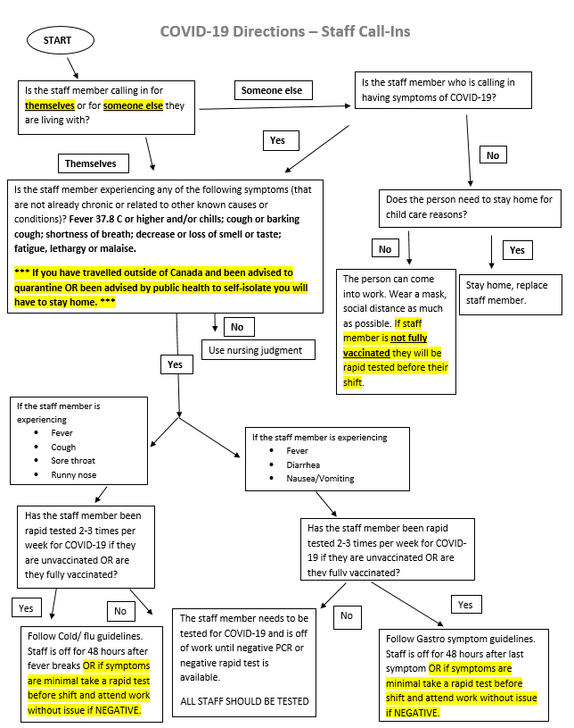
COVID-19 MASKING

As of June 26, 2023 Medical grade masking will be no longer mandatory for staff, caregivers, entertainers, and general visitors. At this time if staff are to be in close contact to residents during care for longer than 15 minutes. Masking is recommended but not required. Staff are required to perform a point of care risk assessment and determine if wearing a mask should be required. IPAC lead and RN supervisor will oversee and manage symptoms within the home to adjust these policies as necessary. Masking requirements may be subject to change as per EOHU and Ministry of Health and Long-Term Care guidelines/regulations.

Please note: Family members may and have full authority to request that staff wear a medical mask when in direct contact with their loved one during care.

Acceptable exceptions to the universal masking directive within long-term care are any reasons outlined in the relevant Ontario directives for COVID-19. A written medical document is needed for Sandfield Place to accept any exceptions to universal masking, otherwise entrance into the home WILL NOT BE PERMITTED.

Those providing proof of medical documentation with an exemption to wearing a medical grade mask, will be required to wear a full-face shield as an alternative with NO EXCEPTIONS.

Resident Masking

All residents within the facility are encouraged to wear a facemask (either medical grade or non-medical grade) while receiving care and while located in common areas where they may come into contact with other residents. Exceptions to masking for residents may be as follows:

- A resident refusing to wear a mask as per their decision
- Cognitive impairment that causes confusion or inability to continuously wear a mask
- A medical condition that contraindicates wearing a mask (respiratory condition, cognitive impairment that may potentiate a risk for choking, entrapment in a mask, ect.)

LEAVE OF ABSENCES (LOAs) – COVID-19

It is preferred at this time that residents are accompanied with a fully immunized care giver. Upon return/admission/transfer back to facility the following will take place.

Residents will be actively screened upon entry and be subject to isolation and testing if symptomatic.

Residents who are asymptomatic will not require a rapid test or PCR test following the absence. Isolation is not required during asymptomatic surveillance unless they become symptomatic and a positive test result is received. However enhanced symptom screening will increase to twice daily for 10 days following admission or re-admission even when asymptomatic.
If known exposure to COVID-19 during absence resident will be actively screened for symptoms on arrival. If resident becomes symptomatic only then will they require PCR and RAT testing as per current EOHU directives.

- For the latest legislation regarding absences away from the home and the readmission processes, see the latest Ontario COVID-19 directives pertaining to long-term care sector.
COVID-19 Directions- Swabbing Residents for COVID-19 during Admissions, Re-admissions, and following Absences

***If at any point you receive a positive result***:
1. Start a resident line listing and fax to health unit.
2. Isolate resident and co-resident(s) who are affected
3. Notify POA’s, Dr., IPAC Nurse
Suspect outbreak: one lab confirmed COVID-19 case in a resident
Confirmed outbreak: Two or more lab confirmed COVID-19 cases in residents

COVID OUTBREAK SEATING PLAN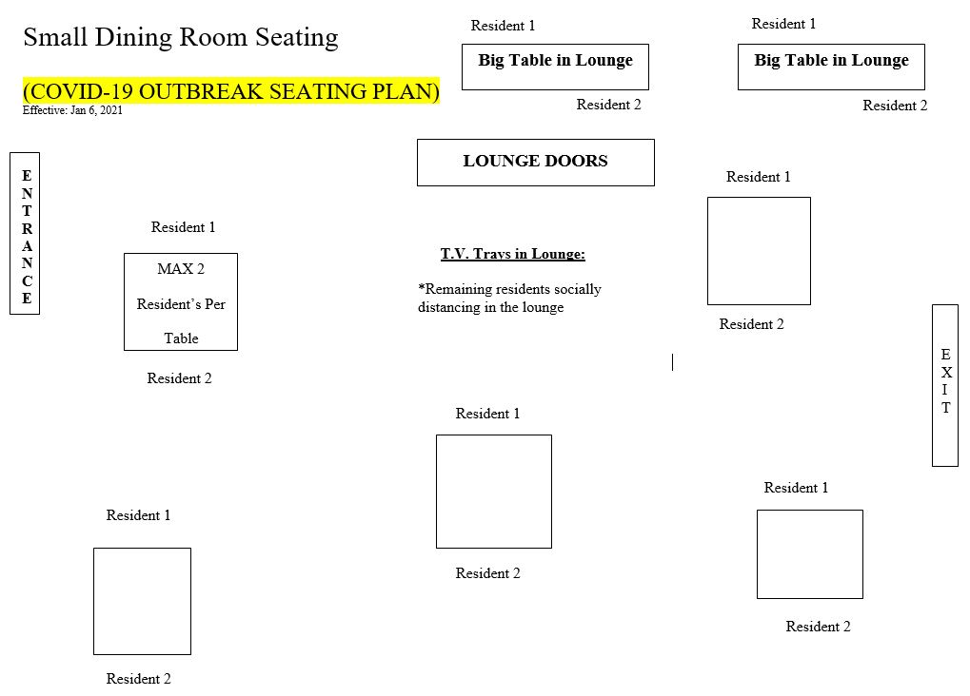
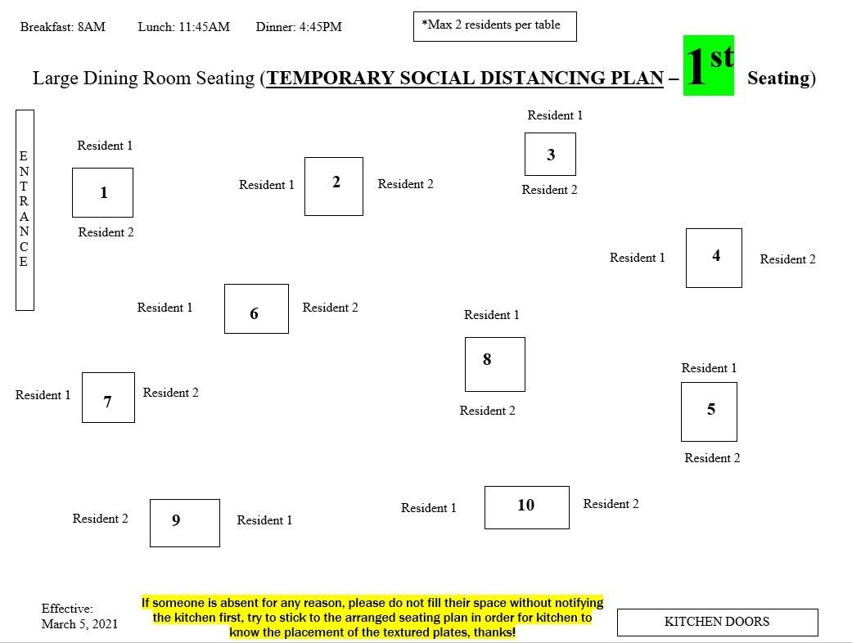

However in the event of an outbreak within the home (if resources are available) all attempts will be made to provide tray service to residents and keep them isolated to their rooms as much as possible.

VISITS WITH RESIDENTS

ALL residents have the right to designate FOUR essential caregivers from their families and friends to ensure they are able to have social interaction. At this time, if the essential caregivers are to visit indoors, they need to be up-to-date with their COVID-19 vaccination status.

As the situation changes there will be new directives. Please stay tuned
As per the Ontario governments reopening plan, they want to have families/ loved ones meet inside and outside in a safe manner. There are some rules that accompany these new guidelines. Rules must be adhered to in full, otherwise; visits will NOT be permitted in accordance with MOHLTC guidelines. Visitors will be escorted out of facility if rules are not adhered to or if staff or others are disrespected in any way by any visitor.

Rules for Indoor Visits

- Indoor visits can occur if desired by residents and/or visitors (space permitting)
- As of March 31st, 2023, no maximum limit for visitors will be enforced. The home reserves the right to limit the number of visitors inside if space accommodations cannot be made to safely allow visitors in the facility for every resident.
***In the event of end-of-life care or a sudden change in resident status unvaccinated caregivers and general visitors will be allowed to enter facility and be escorted directly to residents’ room. Number of visitors will be reviewed on a case-by-case basis by the infection control team. ***

Rules for Outdoor Visits

- Outdoor visits are encouraged on facility property. The maximum number of visitors will vary depending on space available in order to ensure all residents have an equal opportunity for visitation with family and friends. Children under 2 years of age do not count against the number. As of March 31st, 2023, the following changes will be enacted for outdoor visits:
- The essential caregiver *can also be present during the visit.

- Visitor are no longer required to be screened for outdoor visits.

- Social distancing will no longer be enforced. Close contact with the resident is permitted.

- Face coverings will no longer be required for visitors nor residents.

- These visits no longer have to be scheduled.
General visitors must stay on Sandfield Place Property and also when your visit is finished, please escort your loved one back to the home.
Please bring your own lawn chair.

* “Essential visitors include a person performing essential support services (e.g., food delivery, inspector, maintenance, or health services (e.g., phlebotomy)) or a person visiting a very ill or palliative resident. Essential visitors also include “essential caregivers” as defined by MLTC and MSAA/RHRA policies, as appropriate.”
* “ General visitors include all other types of visitors who do not meet the definition of an essential visitor as defined above, including social visitors.”
Taken from: Directive #3 for Long-Term Care Homes under the Long-Term Care Homes Act, 2007 Issued under Section 77.7 of the Health Protection and Promotion Act (HPPA), R.S.O. 1990, c. H.7

COVID-19 DINING PROGRAM

While the pandemic is ongoing, social distance dining has been practiced and will continued to be practiced while still meeting Ontario Public Health guidelines for Long-Term Care. As restrictions are lifted, Sandfield Place will still continue to encourage social distancing dining in certain circumstances. Dining room seating plans are reviewed regularly and the interdisciplinary team makes changes wile considering IPAC regulation and guidelines concurrently with MOHLTC requirements. Residents will be reminded to wash hands before and after all meals if and when possible, by all staff. ABHR greater than 70% will be available outside both dining rooms. If residents’ hands are visibly soiled hands to be cleaned with sanitary wipes located in dining room. Special requirements for social distancing dining are as follows:

- Residents that are NOT vaccinated may dine in the communal dining areas, however; there can be no more than TWO residents per table in this circumstance (can be a duo of a vaccinated & unvaccinated residents or two unvaccinated residents).

